Dear Parent,
We trust that you have received the fee bill for your child. We are introducing an online Fee Payment option – through HDFC Bank (Q-fix) for ease of payment and convenience form 01 Oct 2019.
You can follow the steps for the same:
Online Fee Payment
Step 1 – Open School website [www.mbiis.in]
Step 2 – Click on [Fee Payment]
Step 3 –The following window will open. [https://user.eduqfix.com/#/login]
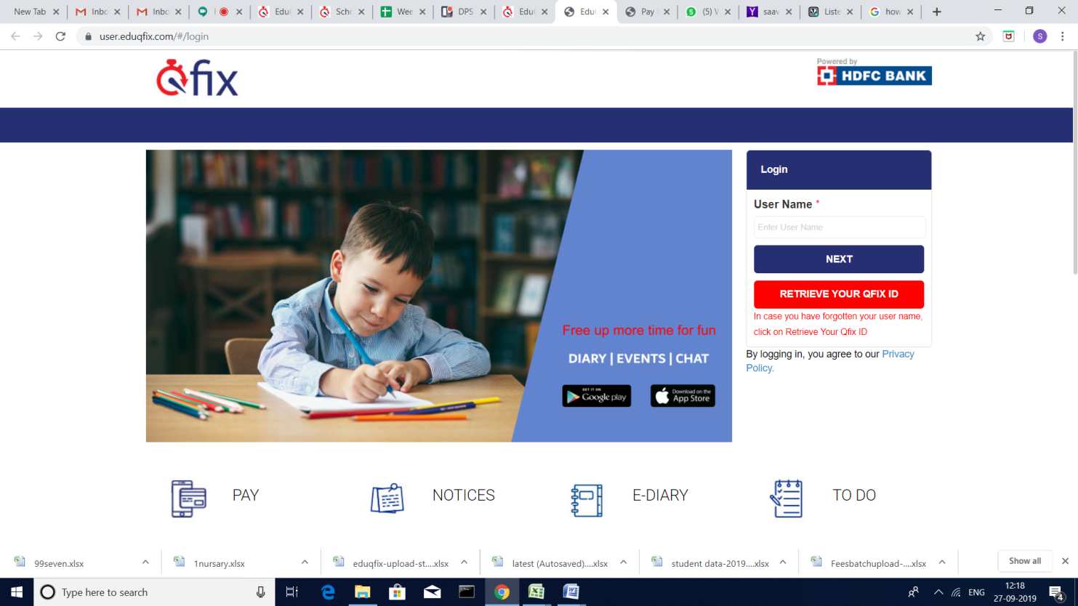
Step 4 - Enter the user name : Admission Number with prefix ‘MB’
For instance, If your admission no. is N1234, then the username would be MBN1234
Step 5 - Click on ‘Next’ button
(you will receive an OTP on your communication mobile number.)
Step 6 - Enter OTP number

Step 7 – Update your profile and Click on Submit /Continue button
Step 8 - Click on ‘LOGIN’
Step 9 - Click on ‘Payments’ option in the top menu bar
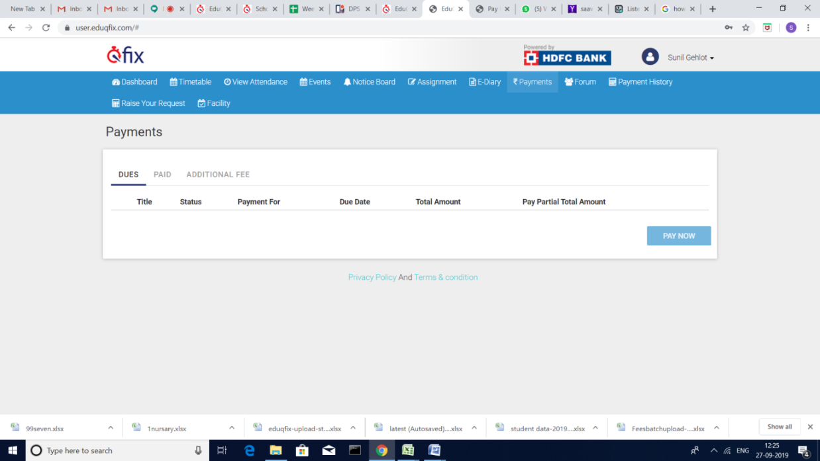

Step 10 - Click on ‘check box’
(If you want to see fee detail then click on ‘ i ’ button)
Step 11 - Click on ‘Pay now’ button
Step 12 - Click on ‘Proceed’ button
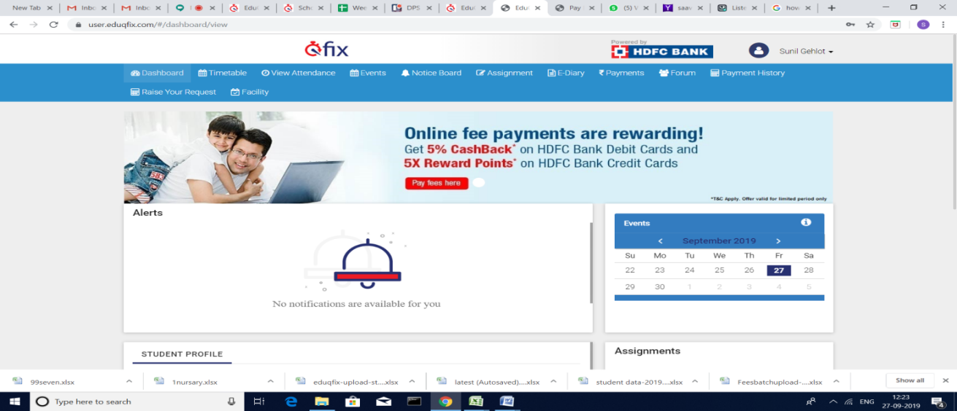
Step 13 - Select payment option & click on ‘Make Payment’ button
Step 14 - Please ensure that the Payment Transaction is successful.
In case of queries:

Technical Support +91 83691 91880 on WhatsApp
Accounts Office + 91 95997 65342

